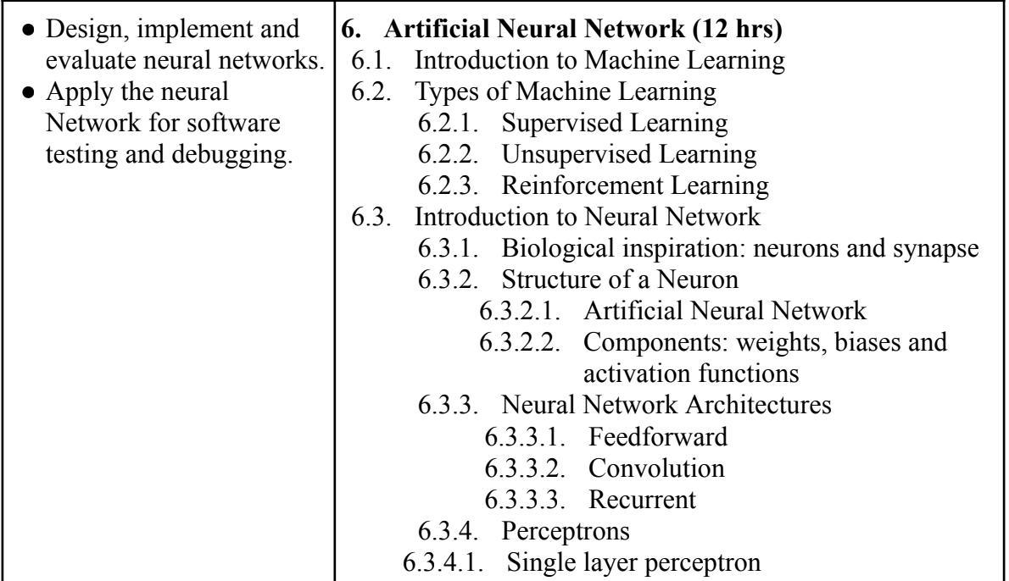

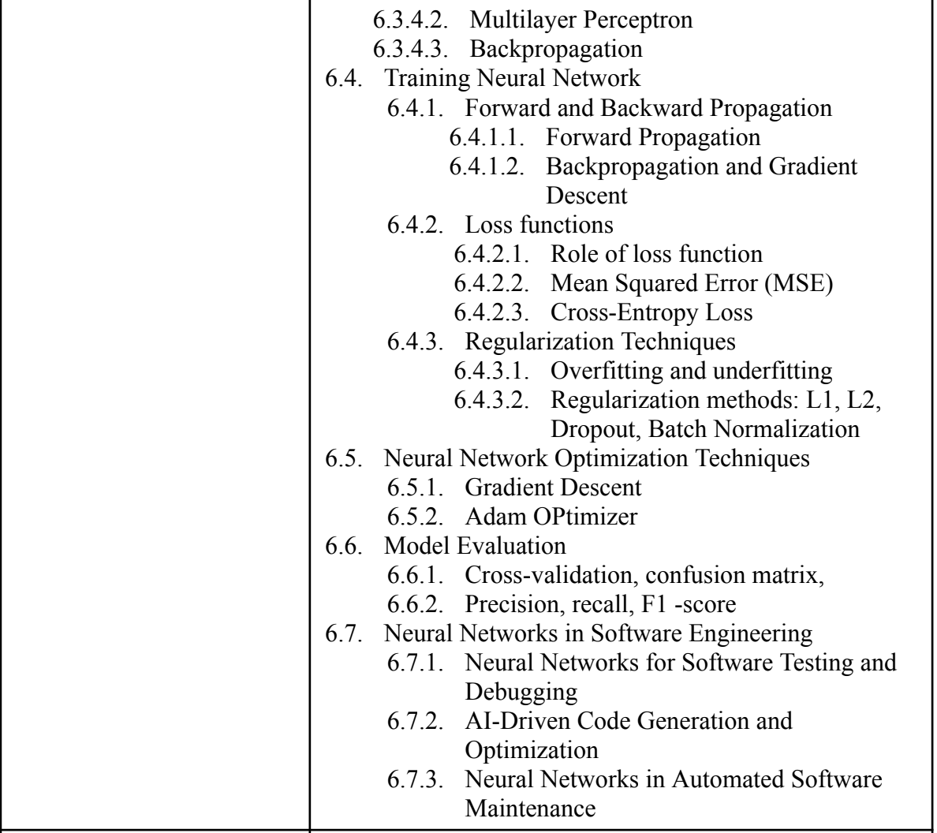

1. Define machine learning and explain its importance in modern software systems. Discuss how machine learning differs from traditional rule-based programming.
2. Explain the three primary types of machine learning: **Supervised Learning, Unsupervised Learning, and Reinforcement Learning**. Provide real-world applications of each.
3. Describe **Supervised Learning** in detail. How do classification and regression problems differ? Provide examples of algorithms used for both tasks.
4. Explain **Unsupervised Learning** and its significance. Discuss clustering and dimensionality reduction techniques with real-world applications.
5. What is **Reinforcement Learning (RL)**? Explain how an RL agent learns through rewards and penalties. Discuss its applications in robotics and game AI.
6. Discuss the biological inspiration behind **Artificial Neural Networks (ANNs)**. Compare biological neurons with artificial neurons in terms of functionality and structure.
7. Explain the architecture of a basic **Artificial Neural Network (ANN)**. Describe its key components: **weights, biases, and activation functions**.
8. What are activation functions in neural networks? Explain the working and significance of **Sigmoid, Tanh, and ReLU (Rectified Linear Unit)** activation functions.
9. Compare different **Neural Network Architectures**, including **Feedforward, Convolutional, and Recurrent Neural Networks**. Discuss their applications in different domains.
10. Explain the working of a **Single-Layer Perceptron**. What are its limitations? How do these limitations lead to the development of **Multi-Layer Perceptrons (MLPs)**?
11. State and Elaborate the **Perceptron Learning Algorithm** in reference with OR logic.
12. Describe the architecture and working of a **Multi-Layer Perceptron (MLP)**. Explain the role of hidden layers in increasing the model's learning capability.
13. Explain the **Backpropagation algorithm** in detail. How does it help in training deep neural networks? Discuss the significance of the **Gradient Descent** optimization technique.
14. What is **Forward and Backward Propagation** in neural networks? Explain their role in updating model parameters during training.
15. Discuss different **Loss Functions** used in neural networks, such as **Mean Squared Error (MSE)** and **Cross-Entropy Loss**. How do they influence model performance?
16. Explain the concepts of **Overfitting and Underfitting** in neural networks. How can **Regularization Techniques** like L1, L2, Dropout, and Batch Normalization help in preventing overfitting?
17. Describe the role of **Gradient Descent** in optimizing neural networks. Compare different variations of gradient descent, such as **Batch, Stochastic, and Mini-batch Gradient Descent**.
18. Explain the **Adam Optimizer** and how it improves gradient descent. Compare Adam with other optimization techniques like **SGD, RMSprop, and Momentum**.